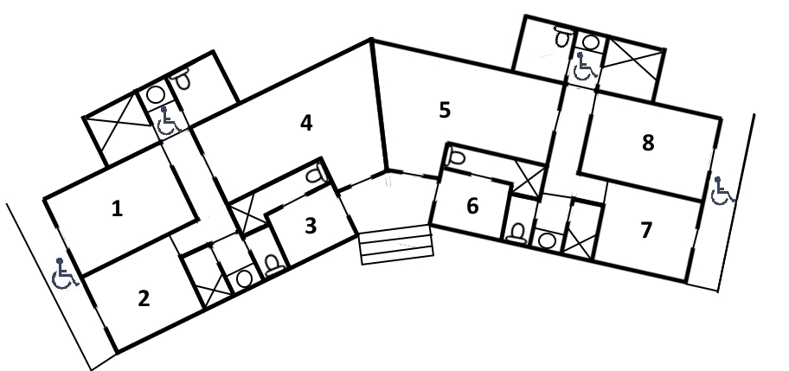
BLUE LAGOON ACCOMMODATION ALLOCATION SHEET

TIGER HEAD BLOCK
Room 1 6 beds |  | Room 8 6 beds
Room 2 4 beds |  | Room 7 4 beds
Room 3 2 beds |  | Room 6 2 beds
Room 4 10 beds |  | Room 5 10 beds

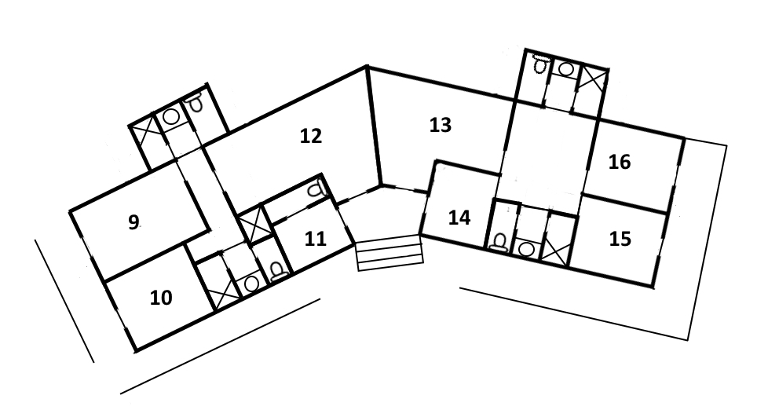
BLUE LAGOON ACCOMMODATION ALLOCATION SHEET

RED OCHRE BLOCK
Room 9 6 beds |  | Room 16 4 beds
Room 10 4 beds |  | Room 15 4 beds
Room 11 2 beds |  | Room 14 2 beds
Room 12 10 beds |  | Room 13 8 beds

APARTMENT |  | **Available subject to Approval**
Sleeps a maximum of 10 |  | (incurs an additional fee)
 |  | 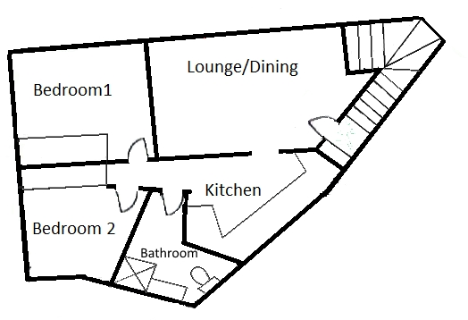
OFFICE QUARTERS
Sleeps a maximum of 2
BLUE LAGOON ACCOMMODATION ALLOCATION SHEET

